**DIGITAL LOGICDESIGN**

**LAB -12**

**SEQUENTIAL CIRCUITSDESIGN**

**SPRING-2016 LABINSTRUCTOR:Muhammad Salman**

**Objective:**Student should understand how to design a sequential circuit given its specifications in sentence structureor state diagram or state tableform.

**1 Perform the IC Testing of JK Flipflop and D Flipflop and from the table understand the phenomena.**

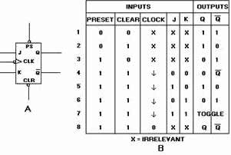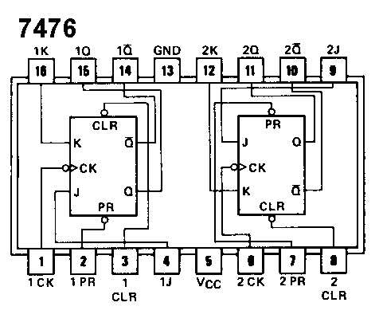



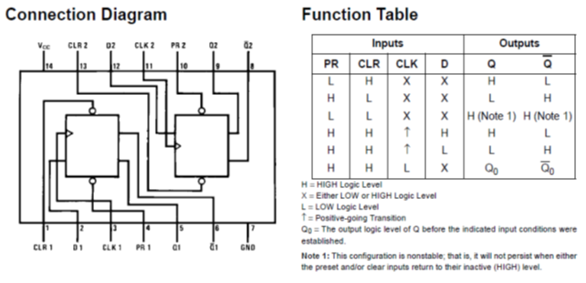

**2 Implement the Master Slave SR Flip Flop using given combinational circuit.**

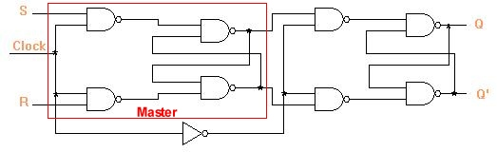

**3Analyze the given sequential circuit. Fill the table given below and mention thefollowing:**

1. Inputequations
2. Output equations
3. Next stateequations
4. Statediagram
5. Q
6. R

D Q

R

A

B

Q0

Q1

Z

|  |  |  |  |  |  |  |
| --- | --- | --- | --- | --- | --- | --- |
| **Current States** | | **Inputs** | | **Next States** | | **Output** |
| **Q0** | **Q1** | **A** | **B** | **Q0 (t+1)** | **Q1**  **(t+1)** | **Z** |
|  |  |  |  |  |  |  |
|  |  |  |  |  |  |  |
|  |  |  |  |  |  |  |
|  |  |  |  |  |  |  |
|  |  |  |  |  |  |  |
|  |  |  |  |  |  |  |
|  |  |  |  |  |  |  |
|  |  |  |  |  |  |  |
|  |  |  |  |  |  |  |
|  |  |  |  |  |  |  |
|  |  |  |  |  |  |  |
|  |  |  |  |  |  |  |
|  |  |  |  |  |  |  |
|  |  |  |  |  |  |  |
|  |  |  |  |  |  |  |
|  |  |  |  |  |  |  |
|  |  |  |  |  |  |  |